**Exercise 1: Configuring a Basic Spring Application**

**Scenario:**

Your company is developing a web application for managing a library. You need to use the Spring Framework to handle the backend operations.

**Steps:**

1. **Set Up a Spring Project:**
   * Create a Maven project named **LibraryManagement**.
   * Add Spring Core dependencies in the **pom.xml** file.
2. **Configure the Application Context:**
   * Create an XML configuration file named **applicationContext.xml** in the **src/main/resources** directory.
   * Define beans for **BookService** and **BookRepository** in the XML file.
3. **Define Service and Repository Classes:**
   * Create a package **com.library.service** and add a class **BookService**.
   * Create a package **com.library.repository** and add a class **BookRepository**.
4. **Run the Application:**
   * Create a main class to load the Spring context and test the configuration.

MainApp.java

**package** com.library;

**import** org.springframework.context.ApplicationContext;

**import** org.springframework.context.support.ClassPathXmlApplicationContext;

**import** com.library.service.BookService;

**public** **class** MainApp {

**public** **static** **void** main(String[] args) {

ApplicationContext context = **new** ClassPathXmlApplicationContext("applicationContext.xml");

BookService bookService = (BookService) context.getBean("bookService");

bookService.addBook("The Spring Handbook");

}

}

BookService.java

**package** com.library.service;

**import** com.library.Repository.BookRepository;

**public** **class** BookService {

**private** BookRepository bookRepository;

// Setter for Spring injection

**public** **void** setBookRepository(BookRepository bookRepository) {

**this**.bookRepository = bookRepository;

}

**public** **void** addBook(String bookName) {

System.***out***.println("Processing the book: " + bookName);

bookRepository.saveBook(bookName);

}

}

BookRepository.java

**package** com.library.Repository;

**public** **class** BookRepository {

**public** **void** saveBook(String bookName) {

System.***out***.println("Book '" + bookName + "' saved to database.");

}

}

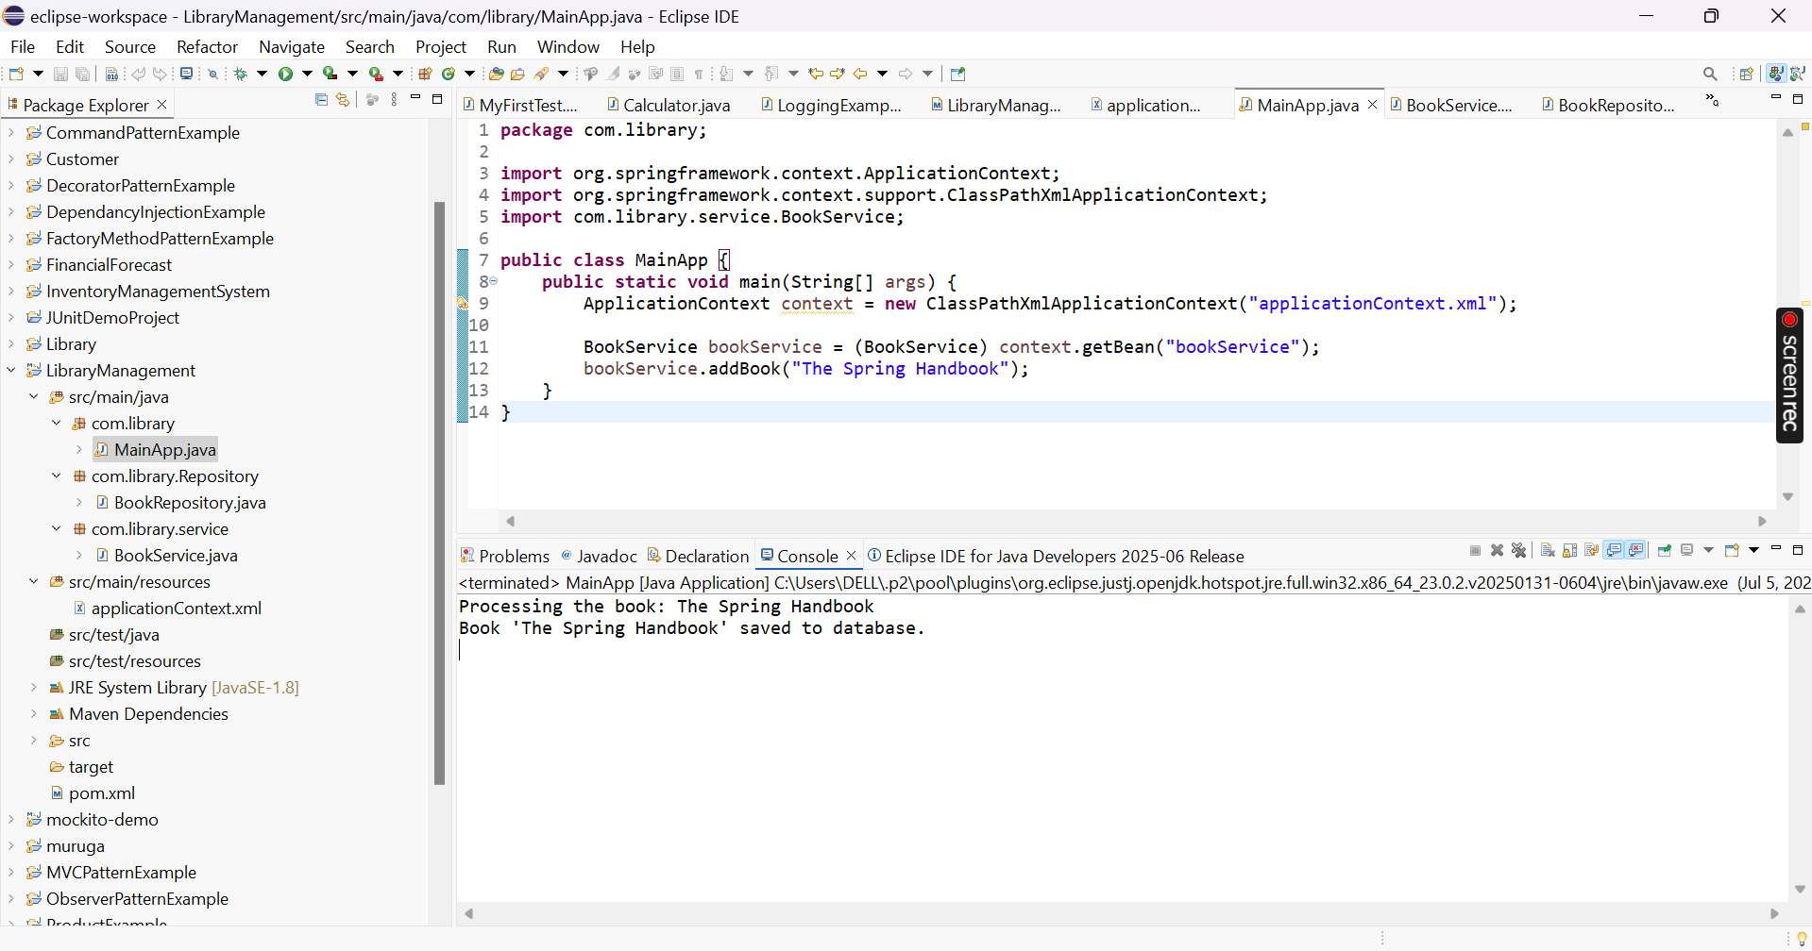

**Exercise 2: Implementing Dependency Injection**

**Scenario:**

In the library management application, you need to manage the dependencies between the BookService and BookRepository classes using Spring's IoC and DI.

**Steps:**

1. **Modify the XML Configuration:**
   * Update **applicationContext.xml** to wire **BookRepository** into **BookService**.
2. **Update the BookService Class:**
   * Ensure that **BookService** class has a setter method for **BookRepository**.
3. **Test the Configuration:**
   * Run the **LibraryManagementApplication** main class to verify the dependency injection.

MainApp.java

**package** com.library;

**import** org.springframework.context.ApplicationContext;

**import** org.springframework.context.support.ClassPathXmlApplicationContext;

**import** com.library.service.BookService;

**public** **class** MainApp {

**public** **static** **void** main(String[] args) {

ApplicationContext context = **new** ClassPathXmlApplicationContext("applicationContext.xml");

BookService bookService = (BookService) context.getBean("bookService");

bookService.addBook("The Spring Handbook");

}

}

BookService.java

**package** com.library.service;

**import** com.library.Repository.BookRepository;

**public** **class** BookService {

**private** BookRepository bookRepository;

// Required setter for Spring's Dependency Injection

**public** **void** setBookRepository(BookRepository bookRepository) {

**this**.bookRepository = bookRepository;

}

**public** **void** addBook(String bookName) {

System.***out***.println("Processing the book: " + bookName);

bookRepository.saveBook(bookName);

}

}

ApplicationContext.java

<?xml version="1.0" encoding="UTF-8"?>

<beans xmlns="http://www.springframework.org/schema/beans"

xmlns:xsi="http://www.w3.org/2001/XMLSchema-instance"

xsi:schemaLocation="

http://www.springframework.org/schema/beans

https://www.springframework.org/schema/beans/spring-beans.xsd">

<!-- BookRepository Bean -->

<bean id="bookRepository" class="com.library.Repository.BookRepository"/>

<!-- BookService Bean with Dependency Injection -->

<bean id="bookService" class="com.library.service.BookService">

<property name="bookRepository" ref="bookRepository"/>

</bean>

</beans>

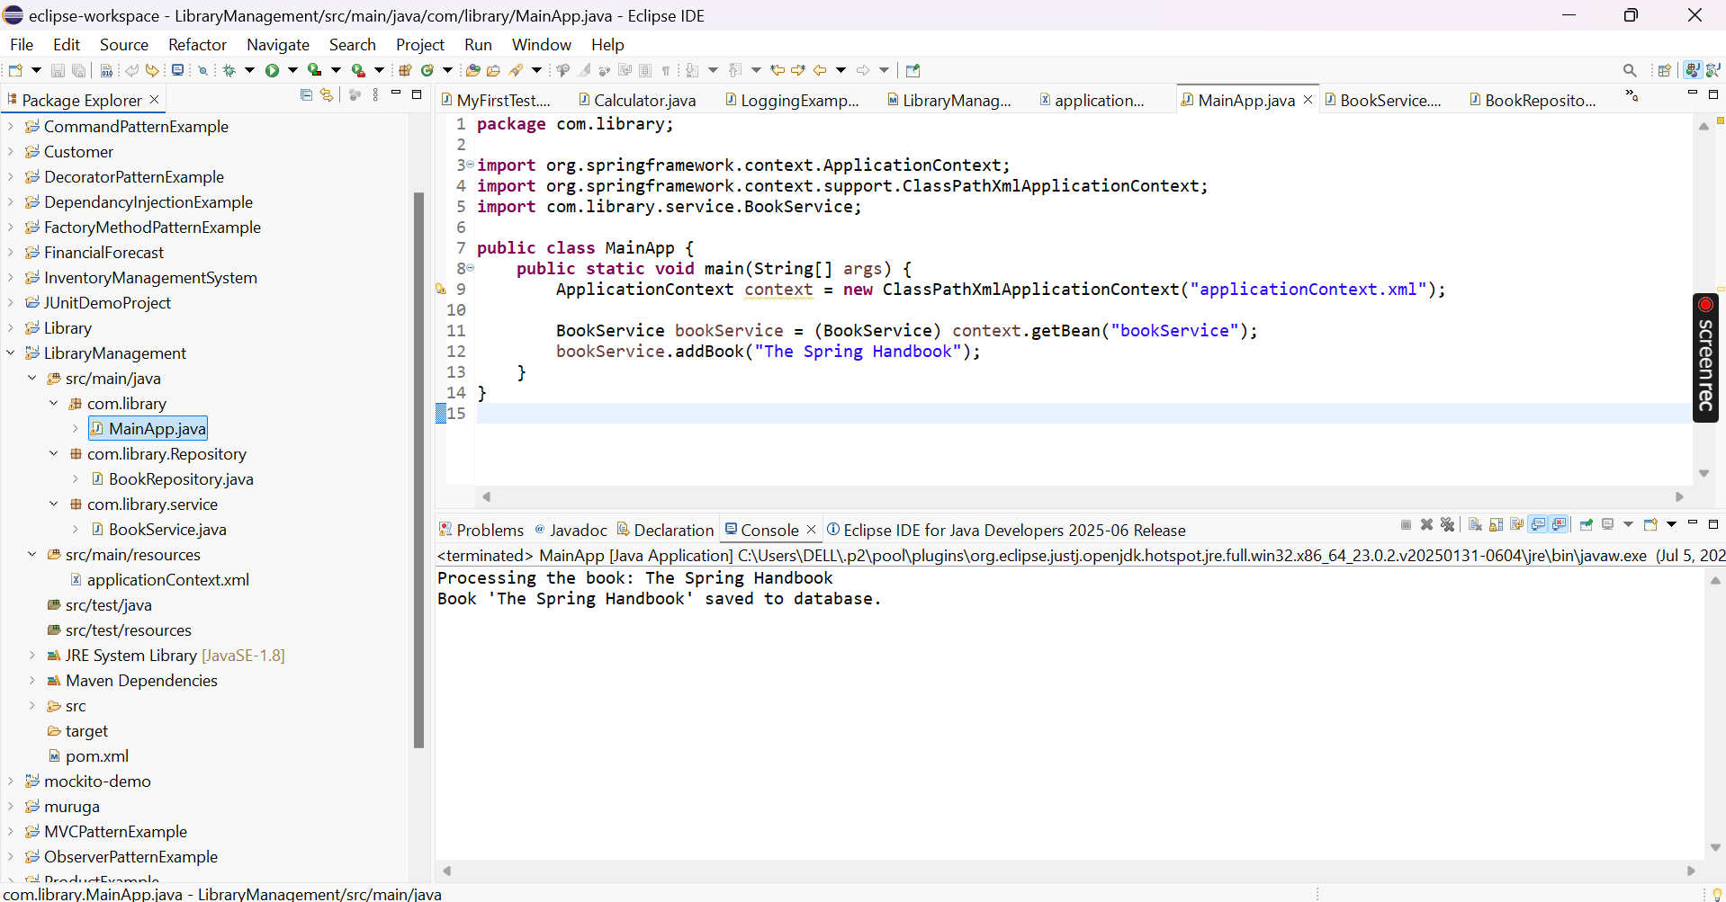

**Exercise 4: Creating and Configuring a Maven Project**

**Scenario:**

You need to set up a new Maven project for the library management application and add Spring dependencies.

**Steps:**

1. **Create a New Maven Project:**
   * Create a new Maven project named **LibraryManagement**.
2. **Add Spring Dependencies in pom.xml:**
   * Include dependencies for Spring Context, Spring AOP, and Spring WebMVC.
3. **Configure Maven Plugins:**
   * Configure the Maven Compiler Plugin for Java version 1.8 in the pom.xml file.

**Pom.xml**

<project xmlns="http://maven.apache.org/POM/4.0.0"

xmlns:xsi="http://www.w3.org/2001/XMLSchema-instance"

xsi:schemaLocation="http://maven.apache.org/POM/4.0.0

http://maven.apache.org/xsd/maven-4.0.0.xsd">

<modelVersion>4.0.0</modelVersion>

<groupId>com.library</groupId>

<artifactId>LibraryManagements</artifactId>

<version>1.0-SNAPSHOT</version>

<properties>

<maven.compiler.source>1.8</maven.compiler.source>

<maven.compiler.target>1.8</maven.compiler.target>

</properties>

<dependencies>

<!-- Spring Context -->

<dependency>

<groupId>org.springframework</groupId>

<artifactId>spring-context</artifactId>

<version>5.3.34</version>

</dependency>

<!-- Spring AOP -->

<dependency>

<groupId>org.springframework</groupId>

<artifactId>spring-aop</artifactId>

<version>5.3.34</version>

</dependency>

<!-- Spring Web MVC -->

<dependency>

<groupId>org.springframework</groupId>

<artifactId>spring-webmvc</artifactId>

<version>5.3.34</version>

</dependency>

<!-- Servlet API (Required for Spring MVC) -->

<dependency>

<groupId>javax.servlet</groupId>

<artifactId>javax.servlet-api</artifactId>

<version>4.0.1</version>

<scope>provided</scope>

</dependency>

</dependencies>

<build>

<plugins>

<!-- Maven Compiler Plugin for Java 1.8 -->

<plugin>

<groupId>org.apache.maven.plugins</groupId>

<artifactId>maven-compiler-plugin</artifactId>

<version>3.8.1</version>

<configuration>

<source>1.8</source>

<target>1.8</target>

</configuration>

</plugin>

</plugins>

</build>

</project>

**Exercise 5: Configuring the Spring IoC Container**

**Scenario:**

The library management application requires a central configuration for beans and dependencies.

**Steps:**

1. **Create Spring Configuration File:**
   * Create an XML configuration file named **applicationContext.xml** in the **src/main/resources** directory.
   * Define beans for **BookService** and **BookRepository** in the XML file.
2. **Update the BookService Class:**
   * Ensure that the **BookService** class has a setter method for **BookRepository**.
3. **Run the Application:**
   * Create a main class to load the Spring context and test the configuration.

applicationContext.xml

<?xml version="1.0" encoding="UTF-8"?>

<beans xmlns="http://www.springframework.org/schema/beans"

xmlns:xsi="http://www.w3.org/2001/XMLSchema-instance"

xsi:schemaLocation="

http://www.springframework.org/schema/beans

https://www.springframework.org/schema/beans/spring-beans.xsd">

<!-- Repository Bean -->

<bean id="bookRepository" class="com.library.repository.BookRepository" />

<!-- Service Bean with Dependency Injection -->

<bean id="bookService" class="com.library.service.BookService">

<property name="bookRepository" ref="bookRepository" />

</bean>

</beans>

MainApp.java

**package** com.library;

**import** org.springframework.context.ApplicationContext;

**import** org.springframework.context.support.ClassPathXmlApplicationContext;

**import** com.library.service.BookService;

**public** **class** MainApp {

**public** **static** **void** main(String[] args) {

ApplicationContext context = **new** ClassPathXmlApplicationContext("applicationContext.xml");

BookService bookService = (BookService) context.getBean("bookService");

bookService.addBook("The Spring Handbook");

}

}

BookRepository.java

**package** com.library.repository;

**public** **class** BookRepository {

**public** **void** saveBook(String bookName) {

System.***out***.println("Book '" + bookName + "' saved to database.");

}

}

BookService.java

**package** com.library.service;

**import** com.library.repository.BookRepository;

**public** **class** BookService {

**private** BookRepository bookRepository;

// Setter for Spring to inject BookRepository

**public** **void** setBookRepository(BookRepository bookRepository) {

**this**.bookRepository = bookRepository;

}

**public** **void** addBook(String bookName) {

System.***out***.println("Processing book: " + bookName);

bookRepository.saveBook(bookName);

}

}

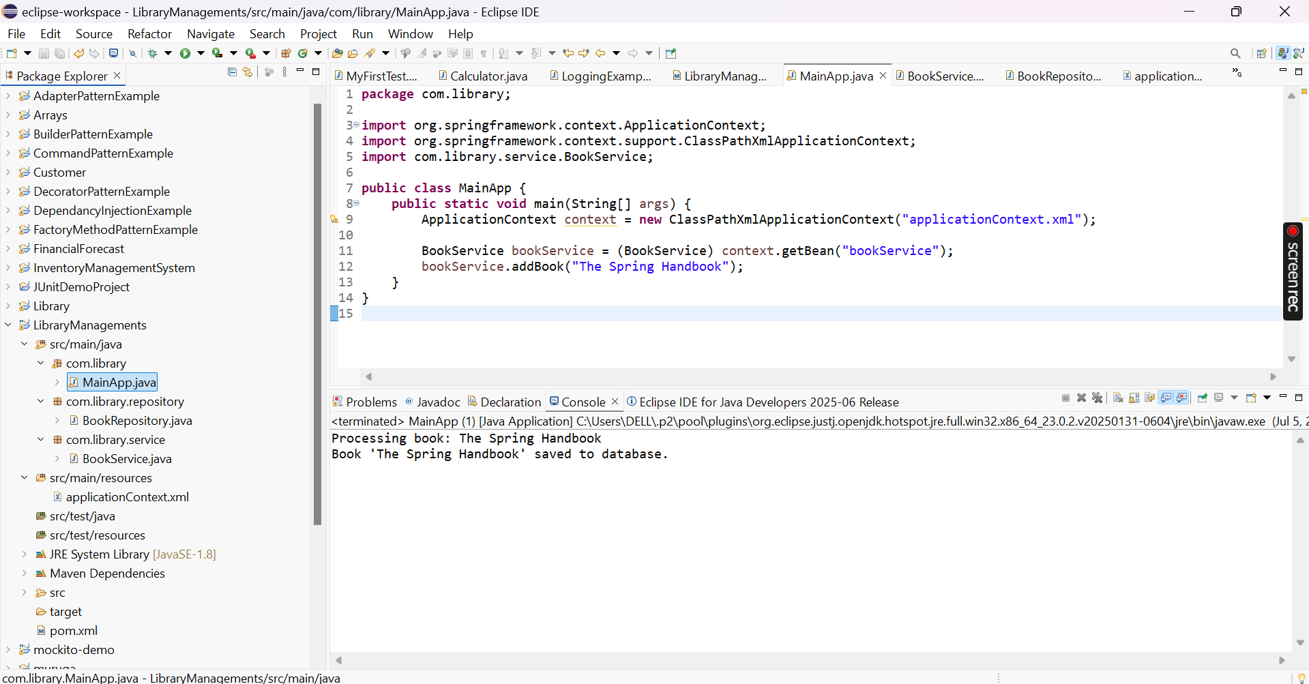

**Exercise 7: Implementing Constructor and Setter Injection**

**Scenario:**

The library management application requires both constructor and setter injection for better control over bean initialization.

**Steps:**

1. **Configure Constructor Injection:**
   * Update applicationContext.**xml** to configure constructor injection for **BookService**.
2. **Configure Setter Injection:**
   * Ensure that the **BookService** class has a setter method for **BookRepository** and configure it in **applicationContext.xml**.
3. **Test the Injection:**
   * Run the **LibraryManagementApplication** main class to verify both constructor and setter injection.

Bookservice.java

**package** com.library.service;

**import** com.library.repository.BookRepository;

**public** **class** BookService {

**private** String serviceId;

**private** BookRepository bookRepository;

// Constructor for Constructor Injection

**public** BookService(String serviceId) {

**this**.serviceId = serviceId;

}

// Setter for Setter Injection

**public** **void** setBookRepository(BookRepository bookRepository) {

**this**.bookRepository = bookRepository;

}

**public** **void** addBook(String bookName) {

System.***out***.println("Service ID: " + serviceId);

System.***out***.println("Processing book: " + bookName);

bookRepository.saveBook(bookName);

}

}

MainApp.java

**package** com.library;

**import** org.springframework.context.ApplicationContext;

**import** org.springframework.context.support.ClassPathXmlApplicationContext;

**import** com.library.service.BookService;

**public** **class** MainApp {

**public** **static** **void** main(String[] args) {

ApplicationContext context = **new** ClassPathXmlApplicationContext("applicationContext.xml");

BookService bookService = (BookService) context.getBean("bookService");

bookService.addBook("Spring Framework Essentials");

}

}

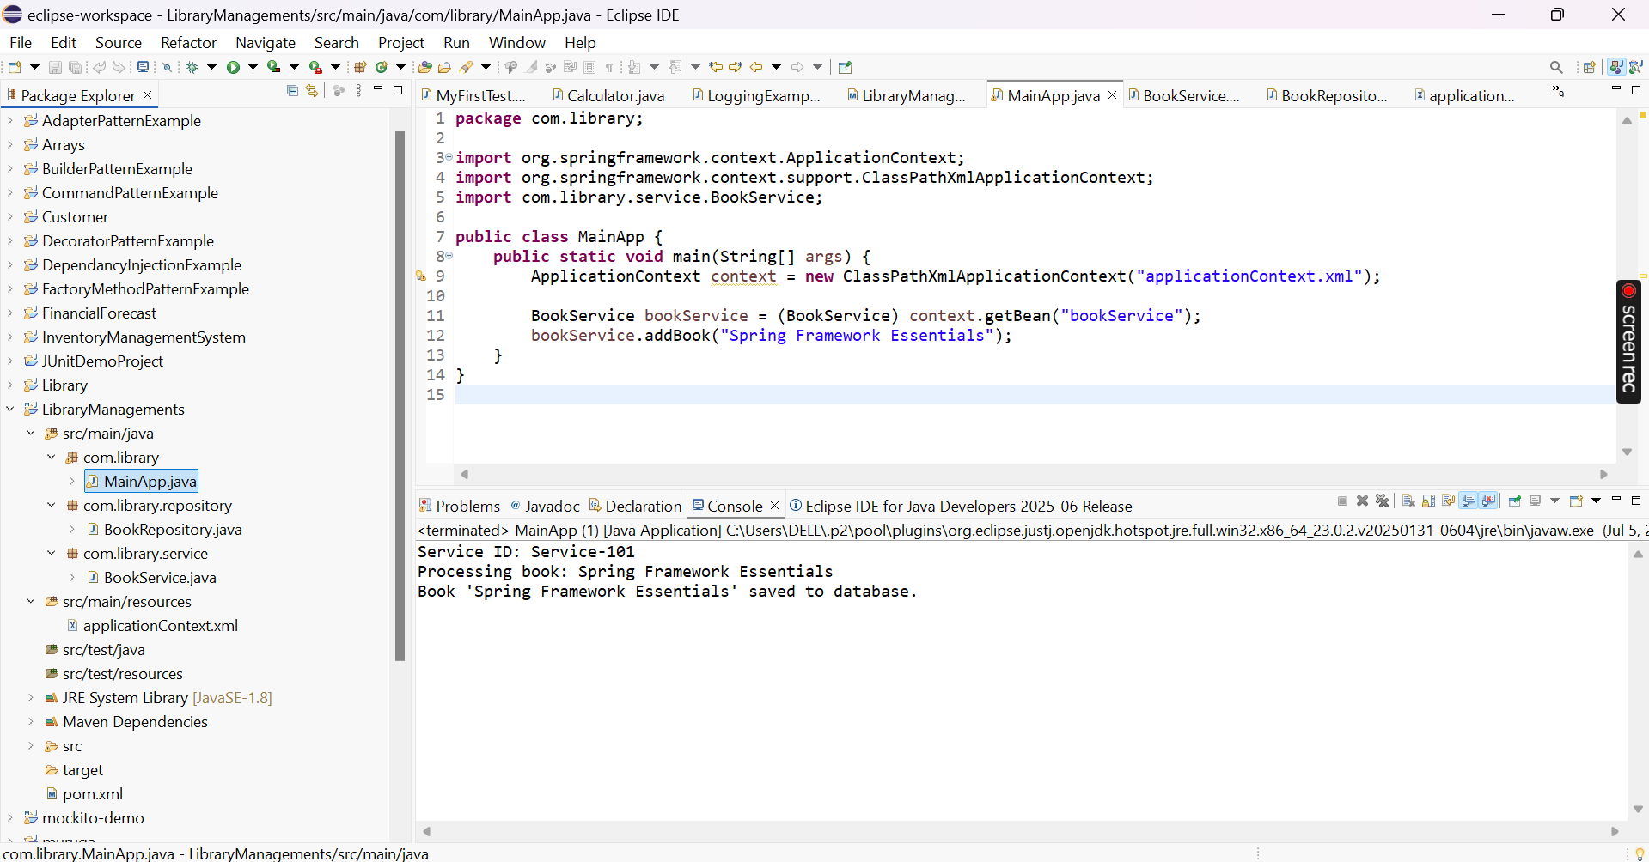

**Exercise 9: Creating a Spring Boot Application**

**Scenario:**

You need to create a Spring Boot application for the library management system to simplify configuration and deployment.

**Steps:**

1. **Create a Spring Boot Project:**
   * Use **Spring Initializr** to create a new Spring Boot project named **LibraryManagement**.
2. **Add Dependencies:**
   * Include dependencies for **Spring Web, Spring Data JPA, and H2 Database**.
3. **Create Application Properties:**
   * Configure database connection properties in **application.properties**.
4. **Define Entities and Repositories:**
   * Create **Book** entity and **BookRepository** interface.
5. **Create a REST Controller:**
   * Create a **BookController** class to handle CRUD operations.
6. **Run the Application:**
   * Run the Spring Boot application and test the REST endpoints.

LibraryManagement.java

package com.Library.LibraryManagemeent;

import org.springframework.boot.SpringApplication;

import org.springframework.boot.autoconfigure.SpringBootApplication;

@SpringBootApplication

public class LibraryManagemeent {

public static void main(String[] args) {

SpringApplication.run(LibraryManagemeent.class, args);

}

}

BackController.java

**package** com.Library.controller;

**import** com.Library.entity.Book;

**import** com.Library.repository.BookRepository;

**import** org.springframework.beans.factory.annotation.Autowired;

**import** org.springframework.web.bind.annotation.*;

**import** java.util.List;

@RestController

@RequestMapping("/books")

**public** **class** BackController {

@Autowired

**private** BookRepository bookRepository;

@GetMapping

**public** List<Book> getAllBooks() {

**return** bookRepository.findAll();

}

@GetMapping("/{id}")

**public** Book getBook(@PathVariable Long id) {

**return** bookRepository.findById(id).orElseThrow();

}

@PostMapping

**public** Book createBook(@RequestBody Book book) {

**return** bookRepository.save(book);

}

@PutMapping("/{id}")

**public** Book updateBook(@PathVariable Long id, @RequestBody Book bookDetails) {

Book book = bookRepository.findById(id).orElseThrow();

book.setTitle(bookDetails.getTitle());

book.setAuthor(bookDetails.getAuthor());

**return** bookRepository.save(book);

}

@DeleteMapping("/{id}")

**public** **void** deleteBook(@PathVariable Long id) {

bookRepository.deleteById(id);

}

}

